**Chemical reactions**

**Thermic reactions and acids**

**Mini test**

**Name:**

1. Describe the movement of energy in an endothermic reaction (1 mark)

|  |
| --- |
|  |
|  |
|  |
|  |

1. Does the substance in an exothermic reaction become hotter or colder? Explain your answer. (2 marks)

|  |
| --- |
|  |
|  |
|  |
|  |
|  |
|  |

1. Computers become hot when they have lots of programs open. State what kind of reaction this is. (1 mark)

|  |
| --- |
|  |

1. Explain your reasons for question 3 (2 marks)

|  |
| --- |
|  |
|  |
|  |
|  |

1. Are exothermic reactions always chemical reactions? Give an example to support your answer (2 marks)

|  |
| --- |
|  |
|  |
|  |
|  |

1. Below is a diagram of a fire. Draw arrows that show the direction of energy (1 mark)

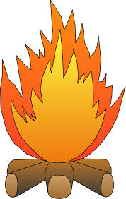

1. Complete the below sentences (5 marks)
   1. Acids taste ____________, conduct _______________ and _______________ metal and skin.
   2. pH measures _______________
   3. Universal indicators are a mixture of chemicals used to accurately check the ____________ of a substance.
2. Use the chart to complete the below table. (6 marks)

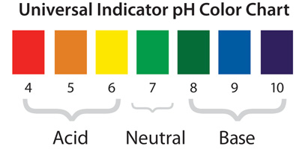

|  |  |  |  |
| --- | --- | --- | --- |
| Substance | Colour after using the universal indicator (cabbage solution) | pH | Describe the acidity of the substance |
| Hydrochloric acid |  |  |  |
| Unknown substance 1 |  |  |  |
| Unknown substance 2 |  |  |  |

Mark: /20 %

Current total for mini tests: /40 %